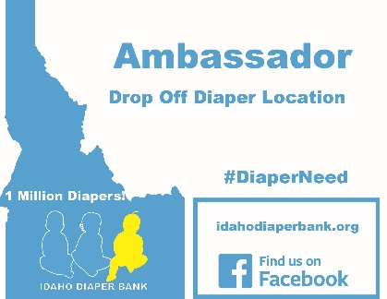 Volunteer Ambassador Program

Do you care about poverty, have a little time, and a little space in your home to spare?

Idaho Diaper Bank is looking for volunteers to serve as Ambassadors around the Treasure Valley!
As an IDB Ambassador, you will help secure much needed diapers by serving as a drop off location in your neighborhood. Thanks to your support, families in your neighborhood will have an easy way to donate their unused, clean diapers. In addition, IDB Ambassadors help spread the word of this important work by sharing IDB’s mission with local family groups, list serves, schools, etc. This is a great way to meet other families in your community, as well as teach your own children about the importance of volunteering and community engagement. We’ll give you the tools, you make the connection! Be a voice for families in your community by signing up to be an Idaho Diaper Bank Ambassador today! To learn more or to sign up, email info@idahodiaperbank.org

AMBASSADORS RECEIVE
- Small yard sign that denotes your house as an “Official Diaper Bank Drop Off Location”
- Car magnet identifying you as an IDB Ambassador
- Toolkit of ideas
- Sample emails for local list serves, e-mail blasts, facebook, etc.
- IDB Staff support

REQUIREMENTS
- Minimum 1 year commitment
- Serve as your neighborhood contact for IDB, promoting your location and coordinating drop-offs with donors
- Spread the word about the urgent need for diapers for families in our community
- Have fun!

